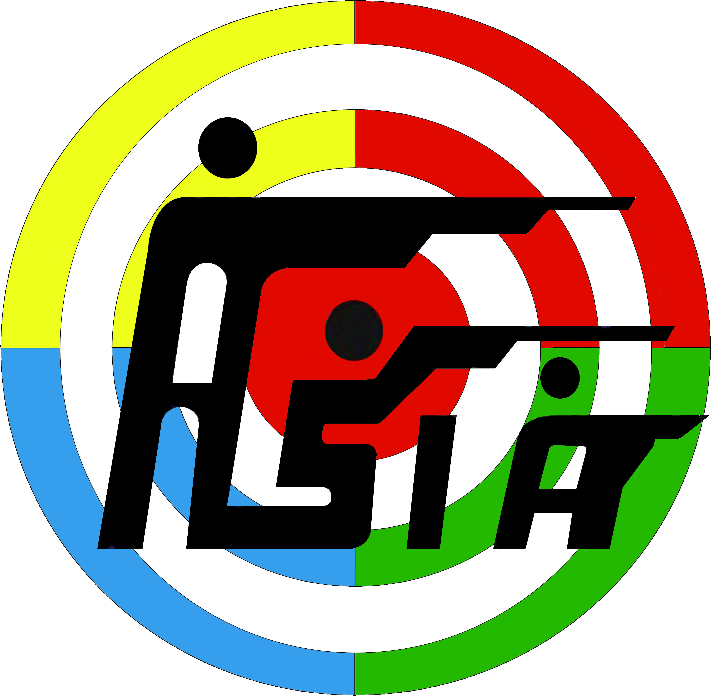
ASIAN SHOOTING CONFEDERATION
HEADQUARTERS

18th ASIAN GAMES – JAKARTA – PALEMBANG (INDONESIA)
18th August – 02nd September, 2018

APPLICATION FORM - FOR THE NOMINATION AS JURY MEMBER

Name of the Shooting Federation:-

Jury Member:

Family Name First Name

Date of Birth

Contact Details:

Address:

Phone: Fax: Email

Rifle/Pistol/R.T Jury Category:
(Please Indicate) Jury of Appeal
Rifle Jury
Pistol Jury
Classification Jury (RTS)
Running Target Jury
Equipment Control Jury

Shotgun Jury Category:
(Please Indicate) Jury of Appeal
Jury
Referee
Event Applied for
Languages Known:-
English: Speak [ ] Read [ ] Write [ ] & Others
Applicants should have officiated at least one (1) International Competition with at least five (5) participating nations in the last two (2) years:- (please list below competitions/championships where you have officiated).

Rifle/Pistol/R.T. Jury must have ISSF ETC (Electronic Target Control) License
Holding ISSF Judges License Category 1. 2 . 3. 4. 5. 6. 7. Valid Until
(Note: You are requested to attach copy of valid ISSF license (both sides), Photo & Passport)

Date: / / Signature of Applicant:

Approved by Federation:
Please fill out this form clearly, either typed or CAPITAL printing.
Deadline for receiving the nominations is 15-August 2017
Please send this form to: asc@asia-shooting.org Fax: +965 24676303

